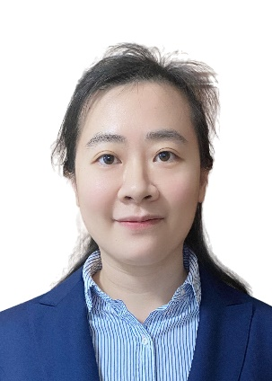

From Earth Observation to SDG Monitoring: Innovations and Practices of SDGSAT-1

Yunwei Tang^{1,2*} & Changyong Dou^{1,2}
1 International Research Center of Big Data for Sustainable Development Goals, Beijing 100094, China
2 Aerospace Information Research Institute, Chinese Academy of Sciences, Beijing 100094, China

Phone Number: 86-18610543986

Abstract:

The 2030 Agenda for Sustainable Development established 17 Sustainable Development Goals (SDGs), but SDG monitoring and evaluation remain constrained by data gaps, insufficient research methods, and uneven progress. Conventional data sources, including statistical surveys, administrative records, and censuses, are often costly, time-consuming, difficult to update frequently, and affected by differences in statistical systems among countries. Space-based Earth observation provides an important technical pathway by offering objective, dynamic, wide-coverage, and historically traceable data support for SDG evaluation and policy-making. However, most existing satellites lack dedicated capability for observing human activities and socioeconomic processes.
SDGSAT-1 was developed to address this need. Designed, developed, and operated by the International Research Center of Big Data for Sustainable Development Goals (CBAS), it is the first scientific satellite specifically serving the 2030 Agenda. With the scientific objective of precisely depicting traces of anthropic activity, SDGSAT-1 carries the Thermal Infrared Spectrometer (TIS), Glimmer Imager (GLI), and Multispectral Imager (MSI). Through coordinated day-night observations of light, heat, and water, it dynamically acquires data describing human activity and its interaction with the natural environment, with overall performance reaching an internationally leading level.
Since the launch of the SDGSAT-1 Open Science Program in September 2022, its data have been freely shared worldwide. By November 2025, SDGSAT-1 had acquired more than 480,000 images, supported researchers from over 110 countries, contributed to more than 230 papers and 17 United Nations reports, and covered more than 20 specific targets under 11 SDGs. Its data have been applied to poverty mapping, disaster response, urban heat-island analysis, and water-quality monitoring. The Sustainable Development Satellite Constellation and the Alliance of Sustainable Development Satellites (ASSA) further provide coordinated Earth-observation support for global SDG monitoring.

Biography:

Dr. Tang Yunwei is an Associate Researcher at the Aerospace Information Research Institute, Chinese Academy of Sciences. She received her Ph.D. degree from Wuhan University in 2013 and was a joint Ph.D. student at the University of Southampton, UK, from 2011 to 2013. From 2018 to 2019, she served as a Visiting Scholar at the University of Texas at Dallas, USA. She is responsible for the SDGSAT-1 Open Science Program, leading its global data sharing and application initiatives. Her research focuses on remote sensing information extraction and sustainable development assessment. To date, she has published over 90 papers, participated in 40 projects, filed 8 invention patents and 4 software copyrights, and authored 7 monographs. She received the First Prize of the Natural Resources Science and Technology Award in 2024 and was selected for the “Western Light” Talent Program in the same year.

Presenting author details
Full name: Yunwei Tang
Contact number: 86-18610543986, tangyw@aircas.ac.cn
Twitter Acc:
Session Theme: Remote Sensing and GIS
Category: Oral presentation

